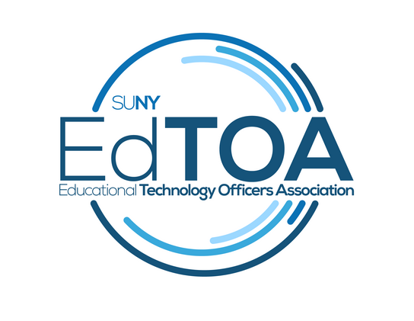
Agenda
EdTOA Exec conference call
1:00 p.m. on Thursday, October 11th, 2018
Zoom Link: https://zoom.us/j/6077785657
- Call to Order
  - CTO@1:02PM
  - Present: English, Kenyon, Larrivey, Meyers, Romero, Stoner, Taverna, Tucci
  - Absent:
- Approve previous meeting minutes
  - Motion: Mark Second: Cindy
- Old Business
  - Website
    - Meet Ed - had 3 people submit
  - Crestron @ CPD - moving to March or later
- New Business
  - Fieldtrip to Maritime - not like a traditional EdTech forum, a tour of facilities on ship; something we’ve never seen; possible weather concerns due to timing;
  - Bill getting responses to call for EdTech Forums
  - Add to old business conversations on future forums as discussed in the external liaison section
- Reports
  - Vice-Chair
    - Getting more Meet Ed submissions to post; what is the possibility of sharing large equipment that usually only gets usage once or twice a year across campuses? Perhaps some sort of equipment sharing list? Regional sharing? Drew - EdTOA started with a regional model of equipment sharing. One problem was often one-way borrowing. Another problem was issues of what happens if something gets broken (never happened, but was a concern). As prices on equipment dropped it became easier for campuses to purchase their own equipment. Still might be a consideration now for highly specialized equipment. There used to be a group based out of the Albany region (SUNY SAT) that would come to campuses to do live setup. Perhaps this is something that we could advocate for SUNY to do?
  - Treasurer
    - STC disbursement check received and deposited. We may need to move to a new type of account due to changes from the State.
  - Secretary
    - Approved minutes uploaded to website, draft minutes sent to Exec. Comm.
  - Programming and Practice
    - STC session feedback is compiled, Bill will share with exec board; hopefully more responses through app next year if we promote it better;
  - External Liaison
    - Fermin and Drew to draft a message to external liaisons of other groups
    - reports from CIO meetings were sent out as well as FACT 2
    - Brian Digman filled SUNY CIO position
    - Would support issues, including adjunct issues, be appropriate for a regional forum? Yes.
    - “Today’s favor is tomorrow’s expectation”
    - Future conversation on non-tech heavy conversations; e.g. Design Thinking; finding a more centrally located campus to hold - add to Old Business next agenda for further discussion
  - Membership
    - 5 new people added since last month will be getting emails and phone calls to welcome them
    - Cindy prompted people to submit MeetEds and What’s On My Bench - some have already submitted and some will as soon as their projects conclude. Fermin will submit a What’s On My Bench soon.
- Adjourn
  - Adjourned@1:43PM

