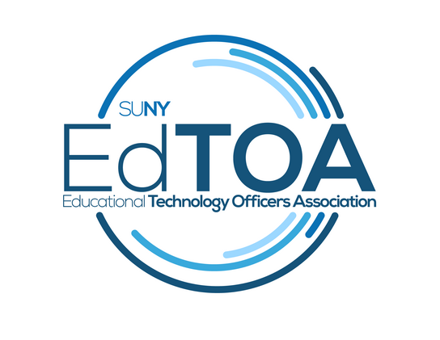
Agenda
EdTOA Exec conference call
1:00 p.m. on Thursday, August 16, 2018
Zoom Link: https://zoom.us/j/6077785657
- Call to Order
  - CTO @ 1:09PM
  - Present: English, Kenyon, Larrivey, Meyers, Romero, Taverna, Tucci
  - Absent:
- Approve previous meeting minutes
  - General Business Meeting Minutes get approved at next GBM
  - Approval of 06-14-18 Executive Committee Meeting
    - Motion: Drew; 2nd: Mark; approved
- Old Business
  - Website
    - Getting classrooms ready for start of semester updates to go up after that, there is content which will be discussed during VP report
- New Business
  - Zoom tip - you can make your Zoom ID the same as your phone number so no need to remember something different
  - Crestron Courses @ CPD
    - CPD is arranging directly with Crestron to set the next batch of trainings up
    - Would it matter on date around Wizard? Looking at dates right before or a few weeks after Wizard. Available dates 10/9-10, or the weeks before (11/5-9) and after (11/26-30) Wizard. Also dates in December, but those dates might not be great. 2 1-day courses. Two platforms, Studio and AV Framework. What is this offering? Is it technical training or a day of marketing? Any of the dates would work. Mark will reach out to Anthony to find out what the offerings are going to be and reach out to CPD with dates.
  - STC debrief
    - Bill has the overall session evals. Largely positive responses it seems. Bill will reach out to McCune about mobile responses. Bill going to create a report for overall STC and one for our sessions. Discussion on different types of presentations and would there be value in adding different session types to the mix. Idea on sessions on electronic recycling; Keisha at SUNY Maritime, field trip to see tech in a ship they have, Ed Tech Forum possibility, time of year concerns for weather? Bill will coordinate this forum field trip.
- Reports
  - Vice-Chair
    - Visited four campuses in WNY: Niagara County, UB, Buffalo State, and ECC. NCCC has a new building with video walls. UB has lots of facilities, great sandbox room. Buffalo State has great kitchen tech for culinary program. ECCC has great nursing set up. Maybe get some more interest in them participating in EdTOA and STC. Within 15 mile radius 50,000-70,000 SUNY students. Will send out notifications for next one day road trips if anyone want to join in. Drew indicated interest in going to campuses in his area. Fermin suggested a trip to TC3.
  - Treasurer
    - STC disbursement will be $5,421.43 - 10% fee ($4,879.29).
  - Secretary
    - Will get approved minutes uploaded to website and these minutes sent to the group
  - Programming and Practice
    - Possible Adirondack forum this Fall?
  - External Liaison
    - FACT2 minutes, page 4 flexspace update; update from doodle - scholarship offered to SUNY people which might help with recruitment goals. Maybe we could sponsor someone or offer scholarship to professional development. Perhaps we can discuss next month as a possible thing we could offer as well. Buffalo State is hiring, classroom support SL3 posting should come out in another few weeks. Next CIO meeting is in September.
  - Membership
    - Would like to know the process for getting people who were interesting in co-chairing involved. Drew explained that assistant chair is up to committee chair and Fermin since there is no change in structure. A co-chair would require a vote from the group. Either way there is one vote for the committee. Fermin shared his support for bringing someone in at Kelly’s discretion.
- Adjourn
  - Adjourned @ 1:55PM Motion: Bill 2nd: Kelly

