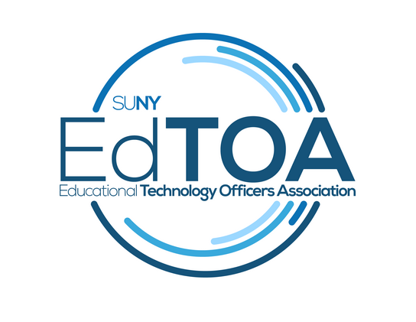
Agenda
EdTOA Exec conference call
1:00 p.m. on Thursday, May 8, 2018
Call-in number: 607-777-3200
Access Code: 26332695
- Call to Order
  - Present: Kenyon, Larrivey, Meyers, Romero, Taverna, Tucci
  - Absent: English, Trapp
  - CTO @ 1:03PM
- Approve previous meeting minutes
  - Approved- Bill motion, Kelly 2nd
- Old Business
  - Website content
    - Next post? - Will revisit next month
- New Business
  - Sessions for STC
    - Schedule is complete - Should be posted on STC website soon
  - Regional form
    - COA is doing a Win10 forum in June announcement out
      - Website announcement

- Reports
  - Vice-Chair
    - No report
  - Treasurer
    - no expected expenditures pre-STC, EdTOA pins were ordered (300), Reusable bags also ordered (200)
  - Secretary
    - No report
  - Programming and Practice
    - Would like to get people to think about offering forums next Fall; need moderators for STC sessions (all found during meeting)
  - External Liaison
    - Notes were attached to agenda - no questions; format of notes is good; GDPR; SICAS initiative fund
  - Membership
    - No report
- Recruit for Fall regional forums at STC - perhaps OCC and BCC can host
- Next Meeting last before STC June 14, 1:00 pm
- Adjourn
  - Adjourned @ 1:27PM

