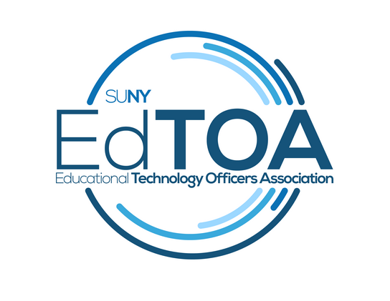
Agenda
EdTOA Exec conference call
1:00 p.m. on Thursday, February 8, 2018
Call-in number: 607-777-3200
Access Code: 89965387
- Call to Order
  - Present: Fermin Romero, Drew Tucci, Mark English, Bill Meyers, Kelly Larrivey, Emily Trapp
  - Absent: Chris Taverna, Melaine Kenyon
  - CtO@1:07pm
- Approve previous meeting minutes
  - Motion: Mark
  - 2nd: Bill
  - Fermin Note: Fermin reiterates his desire towards using EdTOA as a tool for SUNY. Fermin wishes to increase the value of EdTOA as an entity, not just a professional organization of coworkers
- Old Business
  - Website content
    - Next post?
      - Need input and a volunteer to write it. - Mark is continuing to work on the next post. Topic will be on his Albany trip that he took with Fermin. Kyle from Albany did a tour with Fermin and Mark. Mark is looking in to another campus trip soon. Melaine sent Fermin information on a screening room that was recently built. Fermin will update the site with the OCC site that Kelly wrote up. Mark and Fermin will work on other posts from the Albany visit.
      - Kelly suggested a giveaway or prize for people who write a post. Options like a giveaway raffle for everyone who wrote, gifts individually, large prizes or small prizes. Etc..etc...
      - Options on the website came up. Perhaps writing the website to more of a “periodical” feel. 10 ten questions with Mark “What’s on your bench”. Cool Builds. Campus or member of the month..high light corner. Emily will work on “standard conference room design” article
  - Extron Class @ CPD
    - How many signed up? ECP – 8, ECS – 10 Adam is inviting other colleges.
- New Business
  - STC
    - 24 responses. 9 people volunteering to be contacted for presentations
    - We’ll need to finalize our track for March.
    - Invite Avixa again? Follow up on RU credits for infocomm and CTS class in Syracuse.
- Reports
  - Tabled. Ran out of time.
- Next Meeting March 08, 1:00 pm
- Adjourn
  - Adjourned @ 2:01pm

