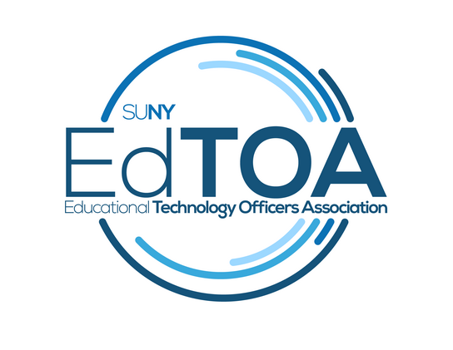
Agenda
EdTOA Exec conference call
1:00 p.m. on Thursday, October 12, 2017
Call-in number: 607-777-3200
Access Code: 39136817
- Call to Order
  - Present: English, Kenyon, Larrivey, Myers, Romero, Taverna, Tucci
  - Absent: Anzalone, Trapp
  - CtO@1:05PM
- Approve previous meeting minutes
  - Motion: Romero
  - 2nd: Tucci
- Old Business
  - Website content - Mark and Fermin met last month. Fermin started a new blog post. Mark will be reaching out to individuals. Would like to have persistent content on website content.
  - CPD Extron - Dates have been picked - 3/19-3/23 Extron Control Specialist + Extron Control Professional - M/T Specialist class W-F Pro class - notification will be sent out once classes are scheduled - Registration fee could be waived for SUNY participants. 16 seats available for each class. Possibility to work with Extron to make this an annual or semi-annual event. Need to figure out food (lunch on all days). CPD may have a specific requirement for who can cater events - need to talk to Margaret. Drew & Fermin will work with Margaret for catering questions
  - CPD Crestron – Emily report on what sapphire marketing had to say. - Tabled
  - CPD Project Management for IT – Drew report on what Margaret from CPD can do to help. - Drew spoke with Margaret, she may not have a lead on a trainer for this. Perhaps we can assist with finding a trainer/speaker. Drew will call leads provided by Fermin for IT Project Management speakers in the area.
  - Welcome to our new exec members
    - External Liaison - Melaine Kenyon
    - Secretary - Christopher Taverna
  - Fall EdTech Forums
    - Jefferson Community College – Bill Meyers report on who volunteered to do helpdesk session. Don Horton, Tom Moran, Cliff Peters. cpeters@sunyjefferson.edu - No response from Jefferson, perhaps it was Jamestown that should be contacted? Melaine will reach out to Jamestown (Denise Burbey) to see if they are interested in hosting a helpdesk forum.
    - Westchester – Emily to ask Doug to help her make contact with COA regarding anything. - Fermin will reach out to Emily for update
    - Adirondack – Can do something Dec-Jan. (changed due to retirement?) - Not going to happen with retirement? Perhaps they can do something next year or later this year once the replacement has acclimated themselves.
    - Suffolk Win10 is a go, sponsored by COA
- New Business
  - Roseann’s Retirement - Fermin moves to buy Roseann a gift, approved unanimously. Bill will reach out to Haley to ask about potential gift ideas. Bill will serve as Chair of Programming and Practice for the remainder of the term
- Reports
  - Vice-Chair - Met in Binghamton regarding “What’s on your bench” - EdTOA’s take on emerging technologies - either new or something being tried for the first time. Perhaps create a knowledge base for EdTOA? Include campuses and technology (traffic light icons to indicate if campus experience has been positive/negative/neutral). Also, list of vendors - specializations and contact info. Best practices. Currently flexspace is the only existing space that touches on best practices. What issues with vendors or legal might arise? Need to have it behind a login so it is not publically available to avoid issues. Mark will move forward with development.
  - Treasurer - We have received our STC disbursement and paid our giveaways check - current total with no planned costs coming in except for retirement gift is $16,529.95 - Foundation fees, currently 9%, next year will drop to 2% - fees are charged when we make a deposit rather than with every withdrawal. Fee was $466 this year.
  - Secretary - no report, Fermin will work with Chris to get minutes uploaded to website, Drew will check with Doug and Haley about getting old minutes.
  - Programming and Practice - nothing additional to report beyond forums previously discussed
  - External Liaison - How should CCIO reports be distributed? Drew raised the concern that these be shared as long as it is OK. Approval to share has been granted. Multiple committee reports are shared - SUNY-wide contract, looking at Zoom and accessibility products; Events, Communication, Community, Sector reports. Melaine recommends that she send all to the exec board list, Fermin agrees. Accessibility is big topic currently. Right now websites, but could affect how we do classroom tech in the future.
  - Membership - Hold until next month
- Next Meeting November 09, 1:00 pm
- Adjourn
  - Motion: Fermin
  - 2nd: Bill
  - Adjourned@1:59PM

