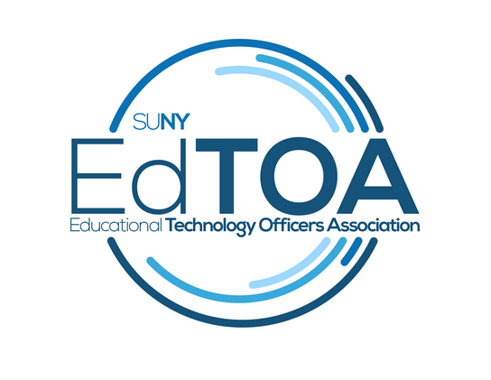

**Minutes**

EdTOA Exec conference call

1:00 p.m. on Tuesday, September 14, 2017

Call-in number: 607-777-3200  
Access Code: 00437038

* Call to Order
  + Present: Tucci, Meyers, Larrivey, Romero, Trapp, English
  + Absent: Anzalone
  + (1:07)
* Approve previous meeting minutes
  + Emily Trapp Motion
  + Meyers 2nd
* Old Business
  + Fall EdTech Forums
    - Jefferson Community College – Bill Meyers to reach out and find out who had volunteered to do helpdesk session. Don Horton, Tom Moran, Cliff Peters. cpeters@sunyjefferson.edu
    - Suffolk – October forum – Emily to reach out to Doug regarding if this has been canceled or if this is a COA sponsored event
    - Westchester – Emily to ask Doug to help her make contact with COA regarding anything.
    - Adirondack – Can do something Dec-Jan
    - Larger Group – Fermin to reach out to entire board
* New Business
  + Website content
    - Emily to email Fermin about potential conferences to post about on EdTOA site
  + CPD Courses
    - CPD Extron – Tucci to reach out to Zonis at Extron to feel out if they are interested again in hosting something here in Syracuse
    - CPD Crestron – Emily to reach out to Sapphire marketing to find out who the rep is and also to Margaret at CPD to get info
    - CPD DANTE – Emily to send Margaret the info in order to arrange the training
    - CPD Project Management for IT – Drew to talk to Margaret about it
  + Vacant Positions
    - External Liaison
    - Secretary
  + Wizard? Are we forever out?
    - Fermin to reach out to Mike Notorious regarding what they can do with us rather than include us
* Reports
  + Vice-Chair
  + Treasurer
    - Final disbursement from STC arrived: $4466.09
    - Balance (after foundation 10% fee) = $17,625.27
  + Secretary
  + Programming and Practice
    - STC survey results presented – Bill to provide link to group
  + External Liaison
  + Membership
* Next Meeting October 12, 1:00 pm
* Adjourn
  + Fermin Motion
  + Kelly 2nd