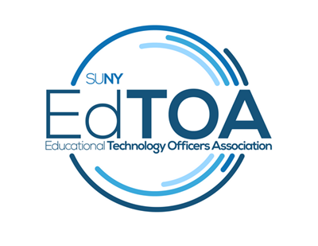
APPLICATION FOR SCHOLARSHIP (Sponsorship)
SUNY Technology Conference 2017
June 20-22
Lake Placid Conference Center, Lake Placid, NY

GUIDELINES: This scholarship is for first time EdTOA attendees or those who have not attended a SUNY Technology Conference in 5 years or more. This grant will cover your FULL CONFERENCE REGISTRATION and MEAL expenses ONLY; the attendee will be responsible for travel and lodging. Value is $220.
Please complete this application and send it as an email attachment to benzintr@buffalostate.edu.
Name: Click or tap here to enter text.
Position: Click or tap here to enter text.
Campus Address: Click or tap here to enter text.
City, State, Postal Code: Click or tap here to enter text.
Telephone (xxx-xxx-xxxx): Click or tap here to enter text.
Email Address: Click or tap here to enter text.
Campus: Click or tap here to enter text.
Will you attend the full 3 days of the conference? Yes ☐No ☐
If not, on what day will you arrive? Click or tap to enter a date.
On what day will you depart? Click or tap to enter a date.
How long have you supported instructional services in SUNY? Click or tap here to enter text.
Have you ever attended STC before? Yes ☐No ☐
If Yes, when? Click or tap here to enter text.
Why should you be chosen for an EdTOA STC 2017 Scholarship?
Click or tap here to enter text.

