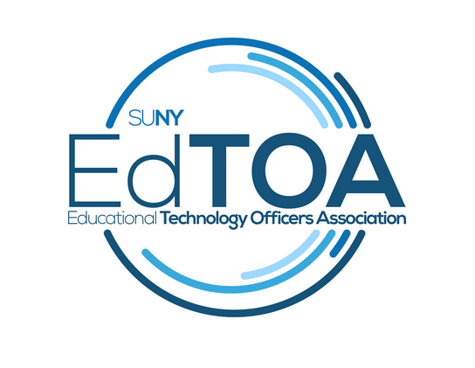

**Agenda**

EdTOA Exec conference call

9:00 a.m. on Tuesday, February 16, 2016

Call-in number: (716) 250-5854

**Minutes**

In attendance: Benzin, Romero, Tucci, Fellendorf, Snyder

Absent: Trapp, Kahn

* Call to Order 9:05 a.m.
* Approval of Minutes from 12/22/15 meeting – unanimously passed
* Old Business
  + STC Proposals
    - a few proposals have come in on Google Docs from the listserv request, Beth will distribute to the group
    - one more push this week for additional topics, will send out current list of suggestions with reminder
    - sessions framework by end of March
    - shooting for 10 or 11 sessions total
  + EdTOA Branded Merchandise
    - shirts are done – Fermin will distribute by STC
    - tablecloths, scarves, mugs, USBs, backpacks are also possibilities
    - will work out website budget to see what is left to spend on swag
    - Fermin will distribute list to Exec Committee of $3000 worth of possible swag for STC (no mugs)
    - 2 week turnaround time for vendor
    - nice backpacks for speakers at STC?
  + Website
    - nothing new to report as of now
    - this month’s goal is for screenshots and possibly mock server
  + Web conferencing smorgasbord
    - Skype for business – Amy Becker, Collaborate - Todd, Fuse – Fermin, Polycom RealPresence – Drew, Joe Smith/Jon Brennan - Zoom
    - Friday in early to Mid-March
    - Todd will contact potential presenters to coordinate a possible date
  + Spring Ed Tech Forum – reaching out to listserve this week
  + Extron Training Scholarships
    - missed that train, but we’ll know for next time – better communication amond coordinators and EdTOA Exec Committee is required
    - birds of a feather for Extron trainees at STC?
      * What worked, what didn’t, future training topics?
    - leave opportunity for Crestron at STC, as well
      * concurrent birds of a feather may work to get everyone involved at once, but leaves little room for those curious or currently dealing with both platforms
    - campus-specific training sessions for Crestron? – Brad points out that NJ trainings provided by Crestron seem to be either too basic or too complicated
    - programmers/software engineers at schools? – topic for STC?
* New Business
  + None
* Reports
  + Vice-Chair Report
    - Nothing further to report
  + Treasurer Report
    - No updates
  + Programming and Practice
    - Nothing further to report
  + External Liaison
    - FACT2 Communications Plan pdf from Brad – Exec Committee should take a look to advance future discussions regarding communication with SUNY constituencies
  + Membership (submitted via email)
    - *I started doing my updates for the membership – and Website.*
    - *Some of you have received my calls and thank you for your valuable information.*
    - *I am devoting at least 3-5 hours a week to the project. Time permitting.*
    - *I hear a lot of desire for the CTS exam – many want and need to get their certifications.*
    - *I am curious to find out if the CTS training (as proposed months ago) is going to happen this year?*
    - *I would love to be able to let EdTOAns know of the plans.*
* Next Meeting Tuesday, March 15 at 9 a.m.
* Adjourn 9:53 a.m.