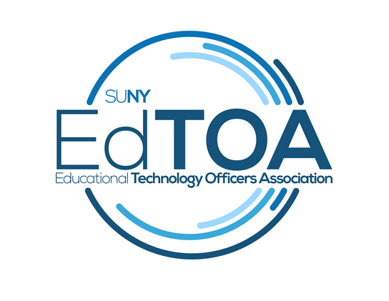

**Draft Minutes**

EdTOA Exec conference call

9:00 a.m. on Tuesday, December 22, 2015

Call-in number: (716) 250-5854

* Present: Todd Benzin, Fermin Romero, Drew Tucci, Beth Fellendorf, Brad Snyder, Emily Trapp
* Vice-Chair Report
  + Fermin has determined that, for now, it seems like the remainder of the website work will be able to completed by him and Mark Irwin from Cortland, with the possible exception of some backbone programming that will be determined later
  + Goal is to be live at STC, with the Executive Committee able to view some previews at the end of March
  + Features of the new website discussed (based on 10 responses from survey received):
    - Listserve registration with a simple required fields form forwarded to Drew (with Captcha feature)
    - Promotions for EdTOA/STC
    - Page dedicated to new hires/retirees
    - Mobile friendly?
    - Better graphical representation of SUNY schools map
    - ADA compliance
  + Ideas for items featuring new EdTOA branding:
    - Embroidered shirts
    - Scarves
    - Umbrellas
    - Jackets
    - Thumb drives
    - Table skirt for conferences
* Treasurer Report
  + Current balance: $19,365.52
  + Last payout was $1599 for EdTOA graphics package
  + Dealing with the new account has had a bit of a learning curve, but has determined it is much easier to cut checks to companies rather than people
* Programming and Practice
  + A drive for more help/ideas will be undertaken after Christmas
  + Web conferencing smorgasbord still in the works for end of January/February
    - Todd Benzin for Blackboard Collaborate
    - Drew Tucci for Polycom RealPresence
    - Amy from Cortland for Skype for Business
    - Joe? – Zoom?
  + Potential EdTech Forum at New Paltz to see Emily’s new Cisco/Mediasite/Crestron super room ☺
* External Liaison
  + Brad will be reaching out to membership to find liaisons for various groups (email to chairs of various groups, contacting interested parties directly)
* Membership
  + Looking to pull data from various SUNY campuses for future use
    - Techs:Classrooms ratios
    - New hires
    - Updating UUP titles/SLs from the ‘70s
    - What we do in AV in a quantifiable sense (different from networking, IT, telecom, etc.) as “digital landscapers” - Drew
  + Thinking of potentially creating whitepapers from EdTOA in the future, as industry voices in the largest University system in the world
* New Business
  + STC Update
    - June 13-16, 2016 in Lake Placid
    - Theme: “The Internet of Things”
    - Keynote David Rose
    - Professional Development having to do with memory
* Meeting adjourned at 10 a.m.

Happy Holidays!

TB