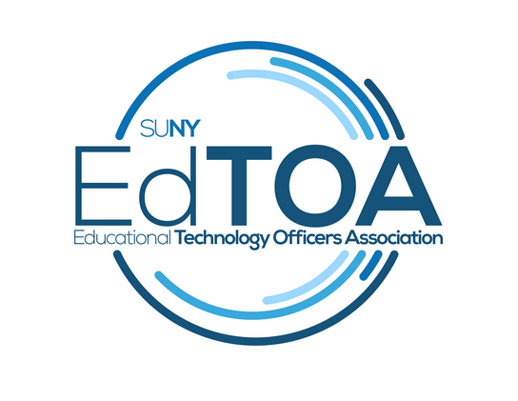

**DRAFT MINUTES**

EdTOA Exec conference call

9:00 a.m. on Tuesday, April 19, 2016

Call-in number: (716) 250-5854

Attendance: Todd Benzin, Fermin Romero, Doug Kahn, Drew Tucci, Emily Trapp

* Call to Order – 9:07 a.m.
* Approval of Minutes – Motion to approve, Drew. Passed by acclimation.
* Old Business
  + STC Proposals – Drew - 10 Sessions plus Business Meeting. There are a total of 12 speakers. Romero has speaker kits ready to go. There was additional discussion on scheduling of sessions, presentation of speaker gifts. Work is on schedule.
  + Website – Fermin demonstrated the website in a FUZE session. He is having issues with ITEC limitations on how his developer can access the server, etc… This is delaying the process, but he expects to be done in June. He demonstrated the site, including discussion on maintenance as well as private content for members. The site is mobile ready.
  + Web conferencing smorgasbord “recordings” – Todd – having some issue with where to put the information out to the group now – easier once the website up. Fermin suggested they build that out in the new website and announcement at STC.
* New Business
  + Listserv Policy – Todd – Drew sent out new policy to the group. There was a discussion about the list and the policy. Doug motioned to approve, Fermin/Emily seconded. Policy is approved by acclimation.
* Reports
  + Vice-Chair Report – Fermin asked if we want us to order jackets for STC and then take orders at STC from the membership. Jackets are $40. We could do as COA did and subsidize the cost by $20 and charge members $20. Fermin can order two, the board can work out if there should be a subsidy and when and where to take orders. Emily motioned to approve purchasing, Todd seconded. Motion passed by acclimation.
  + Treasurer Report – $15,727.38, no further disbursements after a few more backpacks. There are two scholarships for STC. Drew has asked Dan Sidebottom to take the scholarship funds directly from the EdTOA funds distribution from STC.
  + Programming and Practice -
  + External Liaison – no report.
    - Melaine Kenyon from Buffalo State is our new CCIO rep
  + Membership – Emily will be sending a letter out tomorrow for membership updates. Updates will be sent to Fermin. Emily is unsure if she can get to STC.
* Next Meeting: Tuesday, May 17 at 9 a.m.? STC?
* Adjourn – 10:13 a.m.